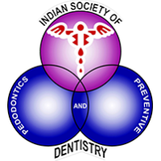

World Oral Health Day

College Logo

20th March-20th April 2023  
 **Be Proud of Your Mouth**



**Organized by**

College Name

**under the aegis of**

**Indian Society of Pedodontics & Preventive Dentistry**