ISPPD PG Conventions
S. No. | Convention | Date | Venue | Organising Secretary | Website
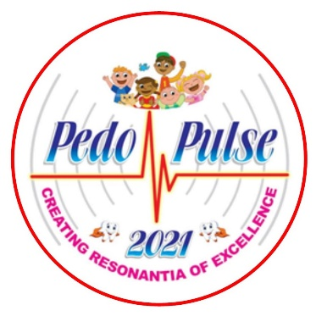 | 18th ISPPD National PG Convention | 25-27 FEBRUARY  2021 | Department of Paediatric & Preventive Dentistry, King George’s Medical University, Lucknow, India | Dr. Rakesh Kumar Chak,  Prof & Head,  Department of Paediatric & Preventive Dentistry,  King George’s Medical University, Lucknow,  Uttar Pradesh -226003.  Mobile: +91 9450849528  E-mail: pedopulse2021@gmail.com | www.pedopulse2021.com

